Player Position Card – 4-4-2

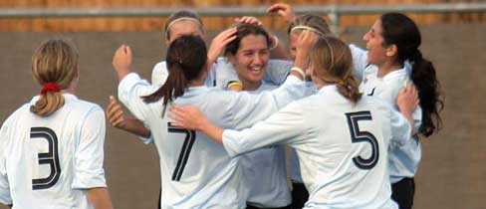
- 10

11 4 8 7

3 6 5 2

1

4-4-2

Roles & Responsibilities of Number 2 (Right Back)

No. 2 – Right Back

- Be Close Enough To Left Winger To Pressure Their First Touch

- Provide Balance To Back Four When Ball Is On Left Hand Side Of Pitch (No Further Than Your Nearest Post) & Drop Deep When Nearest Centre Half Attacks Ball

- Show Opponents Inside Until Level With Penalty Box Then Show Down The Line

- Join The Attack When Team Advancing Down The Right – Look For Opportunities To Overlap

- Take All Throw-Ons Down Right Hand Side (Quickly When Momentum With Us)

